Installing iTKO Lisa Agent

Installation for myAT&T application

# Revision History

|  |  |  |
| --- | --- | --- |
| **Rev Number** | **Date** | **Summary of changes** |
| v1.0 | Aug 23, 2013 | Installation instructions for BEST iAT server / environment |
| V1.1 | Oct 3, 2013 | Added log file maintenance instructions for Lisa Agent. Also added Lisa version upgrade strategy. |

# Contacts

|  |  |  |
| --- | --- | --- |
| Name | Role | Role & Contact |
| Shantam Boinpalli | iTKO Service Virtualization POC for BEST | [sb4542@att.com](mailto:Sb4542@att.com) |
| Mandar Tadphale | iTKO Service Virtualization POC for BEST | [mt4756@att.com](mailto:mt4756@att.com) |
| Data Stubbing Team | AT&T OSD internal contact point for iTKO LISA | DataStubbingTeam@list.att.com |

Table of Contents

Introduction 4

Installation of LISA Agent on WebLogic 4

Pre-requisites 4

Installation Steps 4

Configuring Agent on Oracle WebLogic 6

Verifying Agent Installation 7

Maintenance 7

LISA Agent Log file maintenance 7

LISA Version upgrade strategy 7

Introduction

iTKO Lisa Agent is one of the components of Lisa product suite. It’s typically installed on a server that hosts Java/J2EE container or a server. In our case it would be the Weblogic server used for myAT&T BEST framework. In this document we will only cover one of the known methods of installing Lisa Agent for a Weblogic server.

Installation of LISA Agent on WebLogic

# Pre-requisites

Stubbing team (iTKO team in OSD) needs to provide these files for this installation.

|  |
| --- |
| **Files that stubbing team wil provide** |

|  |  |
| --- | --- |
| Cross-Platform Java Agent | LisaAgent.jar |
| Cross-Platform Pure Java Agent | LisaAgent2.jar |
| Configuration file | [rules.properties](http://www.itko.com/download/release/lisa_remote/rules.properties) |

Note: Stubbing team will make sure they provide latest Agent jars & setup rules.properties.

# Installation Steps

Copy above files on the server that hosts BEST Weblogic server & to a location that has read/write permissions from the java process and not automatically loaded in the application classpath. We need to have all 3 files in a same folder & it advised that the folder doesn’t have any other files since Lisa generates Agent logs in this folder.

Since Lisa supports a pure Java agent for JRE 1.5 and above we will install a Pure Java agent. Make following changes in Weblogic startup script. Start your Java process as you typically do after defining the following environment variable & making change in the java command:

* LISA_OPTIONS=-javaagent:<***path to LisaAgent2.jar***>[=url=<***broker url***>][, name=<***agent_name***>]

Here,

***path to LisaAgent2.jar*** – Specify full path for the agent jar files.

***broker_url*** – Specify Lisa server name & port will be 2009. Stubbing team will provide server name.

***agent_name*** – Agent name can be alphanumeric string. It can be bestIatAgent

* Add LISA_OPTIONS to java command with which you would start Weblogic.

For instance on one of the stubbing environments the following has been defined in the WebLogic startup script (startManagedWebLogicWily.sh):

**LISA_OPTIONS**=-javaagent:/opt/app/q1col1m7/component/LISA_AGENT/LisaAgent2.jar=url=tcp://cacdtd04sb4542.ITServices.sbc.com:2009,name=cef25Agent

${JAVA_HOME}/bin/java ${JAVA_VM} **${LISA_OPTIONS}** ${WILY_BOOTCLASSPATH} ${MEM_ARGS} ${JAVA_OPTIONS} ${WILY_OPTIONS}

-Dweblogic.Name=${SERVER_NAME}

-Dweblogic.management.server=${ADMIN_URL}

-Dcsm-jmx-principal=weblogic

-Dcsm-jmx-credentials=webl0gic

-Dweblogic.ProductionModeEnabled=${PRODUCTION_MODE}

-DVASP_LOG_HOME=${WL_HOME}

-Djava.security.policy="${WL_HOME}/server/lib/weblogic.policy"

-Damdocs.uams.config.resource="res/gen/sum/client"

-Dsl.config.dir=/opt/app/abinitio/QA_CEF/component/cef25/properties

-Damdocs.system.home=/opt/app/q1col1m7/component/cef25App01

weblogic.Server

# Configuring Agent on Oracle WebLogic

This is an alternate approach to configure agent on WebLogic Server. The default install instructions as suggested above apply for WebLogic but to follow the officially supported way to add arguments to the JVM, you can go to the WebLogic administration console and specify the agentpath in there:

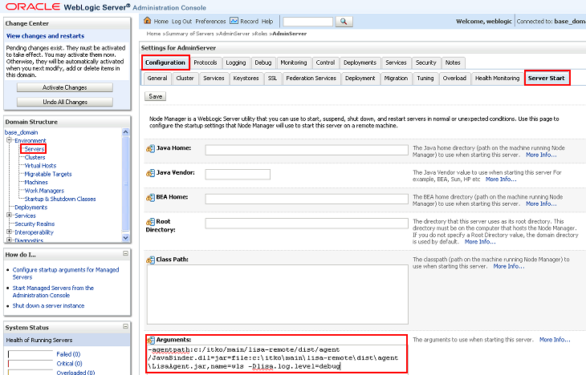

Alternatively, you can edit the **WEBLOGIC_HOME/user_projects/domains/base_domain/config/ config.xml** file and add the **-agentpath** property to the **<server>/<server-start>/<arguments>** node of the target server.

Verifying Agent Installation

Upon configuring properties & starting Weblogic Server, you would see log statements in the Weblogic output log as well as a log file would be written to in the folder where Agent jars are located. If there are issues starting Weblogic server after configuring Lisa Agent, these logs would typically be helpful analyzing the issue. Please contact Stubbing team if you see any issues.

Starting Weblogic after configuring agent jar files in the startup script & seeing logs generating for agent is good indication that it’s configured successfully. But a better verification would be that stubbing team opens Dev Console (another Lisa component) & verify the agent is showing up there & is able to communicate with Dev Console.

Maintenance

# LISA Agent Log file maintenance

LISA Agent creates log files in the same folder where you stored Agent jar files & rules.properties. Every time you restart the Weblogic server, a new log file would be created for agent. These log files are useful for debugging Agent behavior. However log files older than a day can be safely deleted in order to save some space on a hard drive. It’s advisable that either an automated job/task be scheduled or a manual task be performed periodically to purge these older log files.

# LISA Version upgrade strategy

Updated Agent jar files are released by LISA vendor, CA, on their website inside the customer login area. Stubbing team periodically checks for newer version of these jars available & also goes through the release notes to assess if the updated jar file would be useful for myAT&T & DSS implementation of LISA. In a scenario where an important update has been released, stubbing team would download & test the update on a sandbox & will then release it to all environments as necessary. Data stubbing team can be contacted using group distribution email address mentioned in the contacts section of this document.